PROGRAMMING FUNDAMENTAL

LAB TASKS

# Lab Task 01: Write C++ program to print following triangle of stars. Using *nested* for *loop, nested while loop & nested do…while loop.*

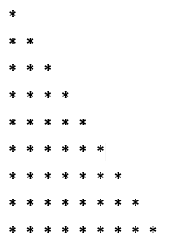

FOR LOOP:

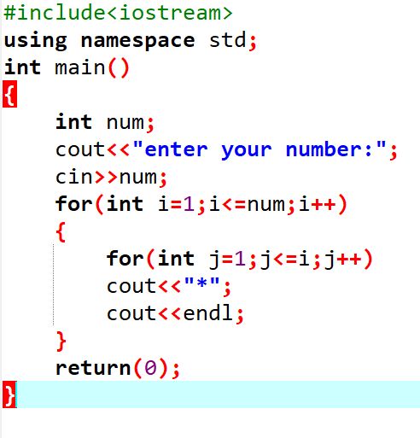

OUTPUT:

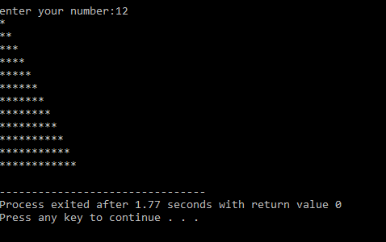

WHILE LOOP:

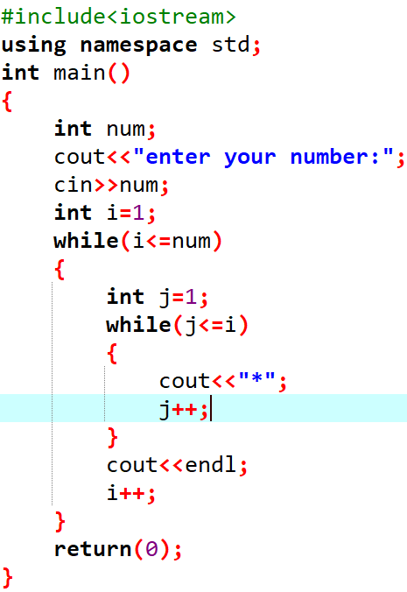

OUTPUT:



DO WHILE:

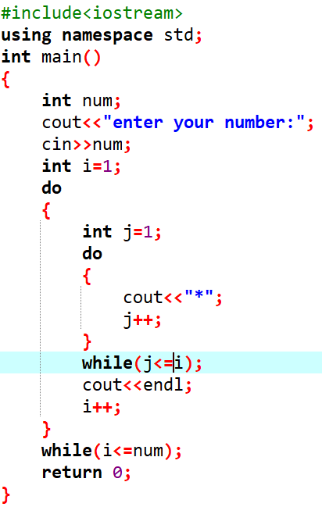

OUTPUT:



# Lab Task 02: Write C++ program to print following Inverted half pyramid of stars. Using *nested* for *loop, nested while loop & nested do…while loop.*



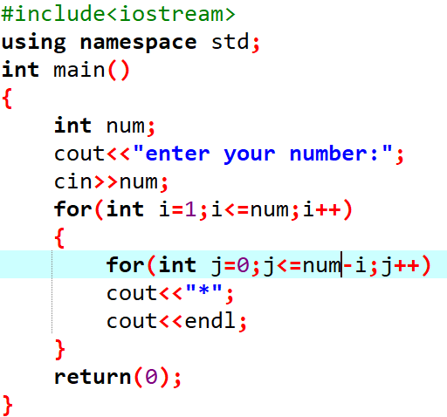

OUTPUT:  
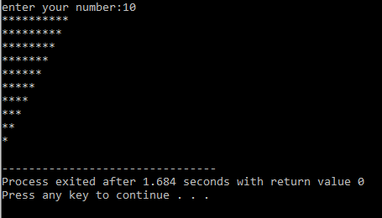

WHILE LOOP  
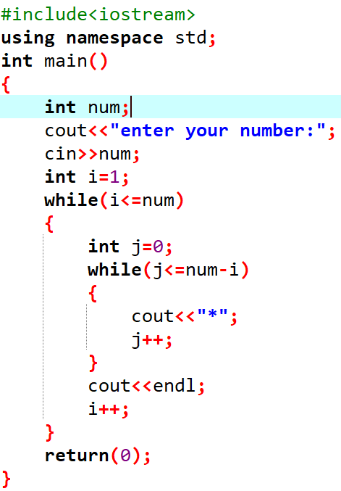

OUTPUT:



DO WHILE:

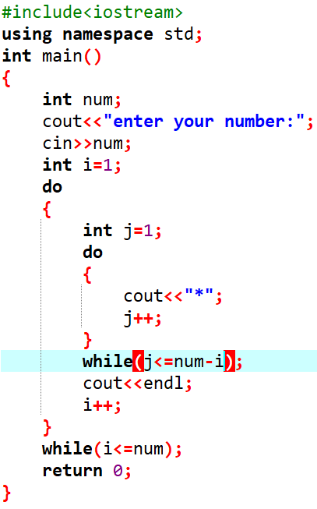

OUTPUT:  


# Lab Task 03: Write C++ program to print following of stars (*).Using *nested* for *loop, nested while loop & nested do…while loop.*

# 

FOR LOOP:

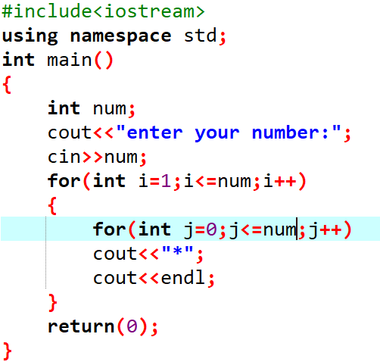

OUTPUT:

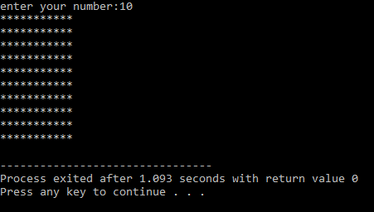

WHILE LOOP:

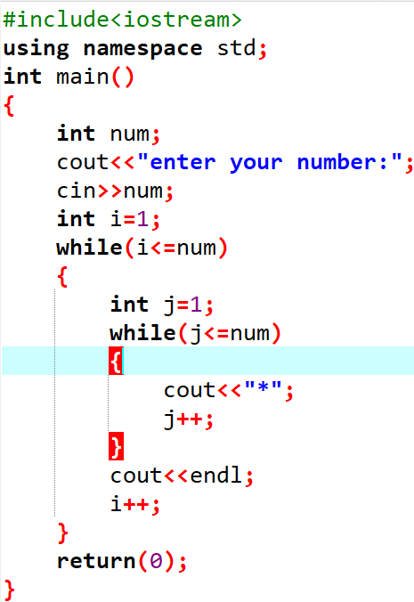

OUTPUT:  


DO WHILE:

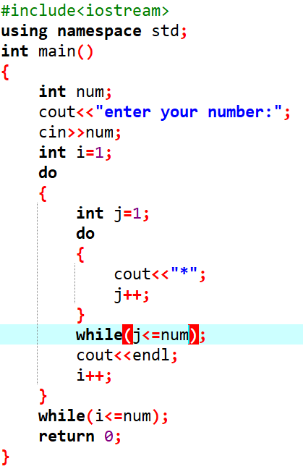

OUTPUT:  
